Think of data as the 3 V’s: volume, velocity, variety, to choose how to ingest the data

Gsutil for uploading files

Storage Transfer Service: When the data is in a different cloud storage provider Or not enough bandwith

Transfer appliance: large quantities of data

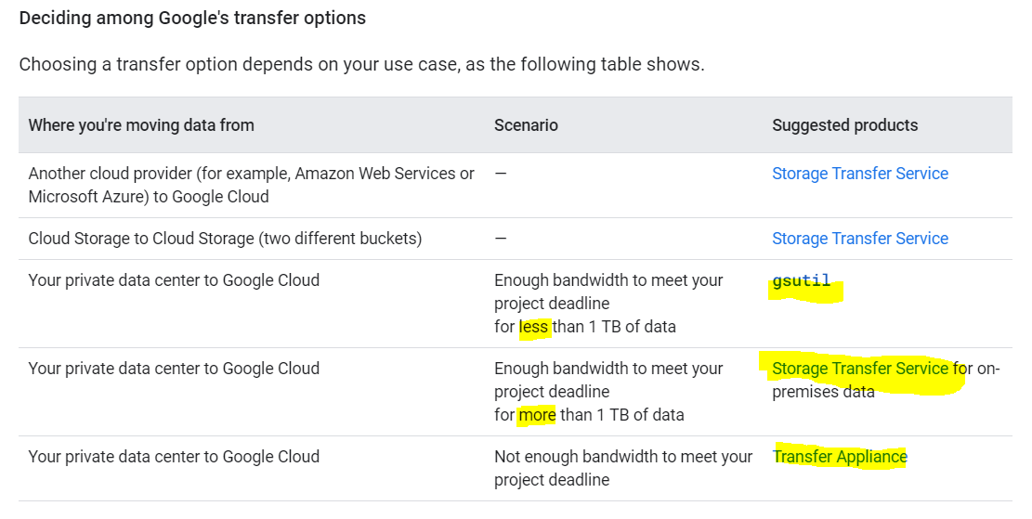

**Increasing network bandwidth:**

**When transfering from Cloud-To-Cloud:**

In a cloud-to-cloud transfer between Google Cloud and other cloud providers, Google provisions the connection between cloud vendor data centers, requiring no setup from you.

**Connecting with a public internet connection**

-Network throughput is less predictable because you're limited by your internet service provider's (ISP) capacity and routing.

- low cost

- Your data will go through the public internet + will go through some hops

**Connecting with Direct Peering (MORE PRIVATE):**

- Access the Google network with fewer network hops than with a public internet connection

- You can exchange internet traffic between your network and Google's Edge Points of Presence (PoPs), **which means your data does not use the public internet.**

**Connecting with Cloud Interconnect:**

-Cloud Interconnect offers a direct connection to Google Cloud through Google or one of the Cloud Interconnect service providers.

- This service helps prevent your data from going on the public internet

- It can provide a more consistent throughput for large data transfers.

**VPC perimiter** allows you to limit the accessible APIs for certain VPC networks. you can specify service perimeters at an organization, folder, or project level. If you don’t want an employee to transfer al your data to his own, local bigquery dataset, you can create a VPC perimeter that only contain the projects related to your organization.

Also, the services that are accessible inside a perimeter, such as from VMs in a VPC network that is hosted inside a perimeter, can be restricted using the **VPC accessible services feature.**